3. Application Layer Functionality and Protocols
introduction

Most of us experience the Internet through the World Wide Web, e-mail services, and

file-sharing programs. These applications, and many others, provide the human interface to the underlying network, enabling us to send and receive information with relative ease Typically
the applications that we use are intuitive, meaning we can access and use them without knowing how they work. However, for network professionals, it is important to know how an application
is able to format, transmit and interpret messages that are sent and received across the network.

Visualizing the mechanisms that enable communication across the network is made easier if we use the layered framework of the Open System Interconnection (OSI) model. In this chapter, we will focus on the role of one layer, the Application layer and its components: applications, services, and protocols. We will explore how these three elements make the robust communication across the information network possible. In this chapter, you will learn to:
• Describe how the functions of the three upper OSI model layers provide network services

to end user applications.

• Describe how the TCP/IP Application Layer protocols provide the services specified by the upper layers of the OSI model.
• Define how people use the Application Layer to communicate across the information

network.

• Describe the function of well-known TCP/IP applications, such as the World Wide Web and email, and their related services (HTTP, DNS, SMB, DHCP, STMP/POP, and Telnet).
• Describe file-sharing processes that use peer-to-peer applications and the Gnutella

protocol.

• Explain how protocols ensure services running on one kind of device can send to and receive data from many different network devices.
• Use network analysis tools to examine and explain how common user applications work.

3.1 Application – The Interface Between the Networks
3.1.1 OSI and TCP/IP Model:-

The Open Systems Interconnection reference model is a layered, abstract representation

created as a guideline for network protocol design. The OSI model divides the networking process into seven logical layers, each of which has unique functionality and to which are assigned specific services and protocols.
In this model, information is passed from one layer to the next, starting at the Application layer on the transmitting host, proceeding down the hierarchy to the Physical layer, then passing over the communications channel to the destination host, where the information proceeds back
up the hierarchy, ending at the Application layer. The figure depicts the steps in this process.

The Application layer, Layer seven, is the top layer of both the OSI and TCP/IP models.

It is the layer that provides the interface between the applications we use to communicate and

the underlying network over which our messages are transmitted. Application layer protocols

are used to exchange data between programs running on the source and destination hosts. There

are many Application layer protocols and new protocols are always being developed.
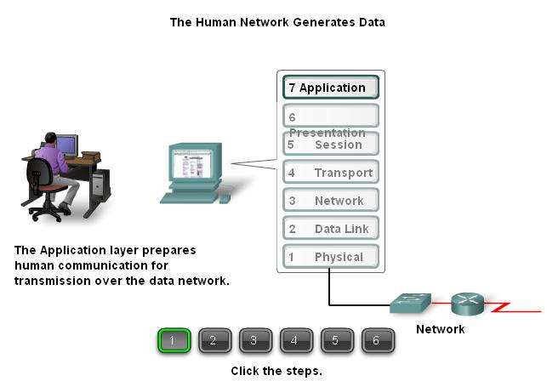
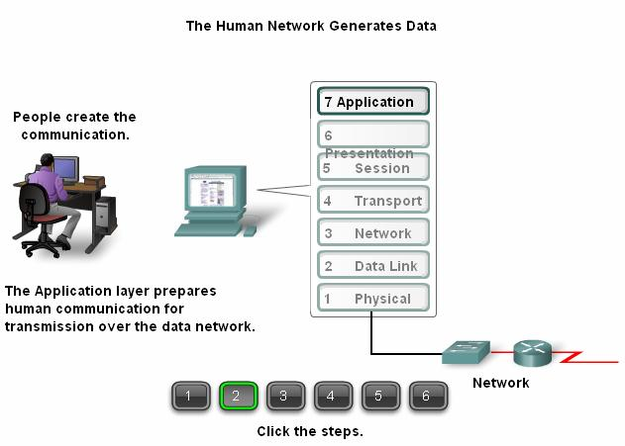

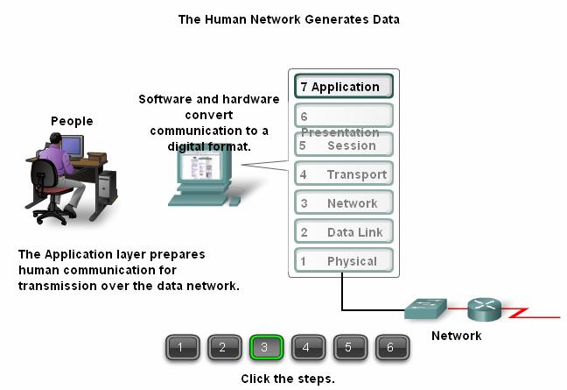

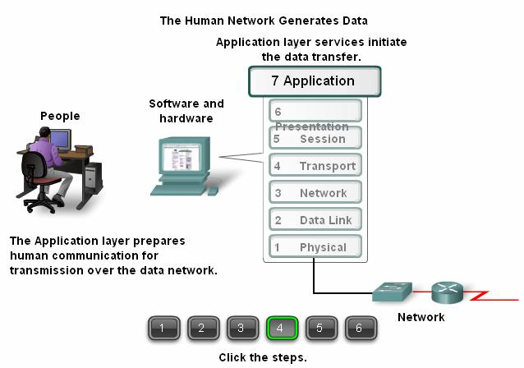

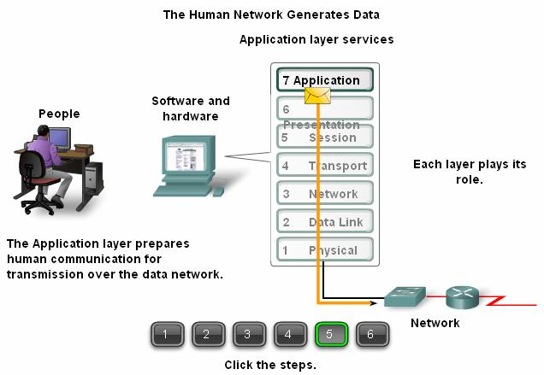
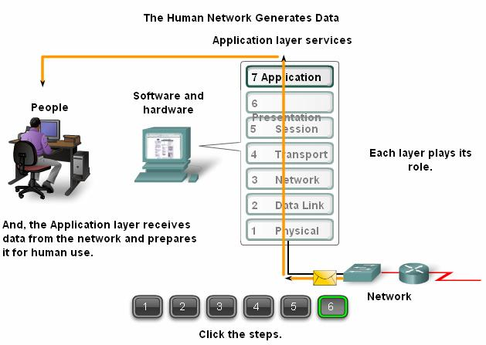

Although the TCP/IP protocol suite was developed prior to the definition of the OSI model, the functionality of the TCP/IP application layer protocols fit roughly into the framework of the top three layers of the OSI model: Application, Presentation and Session layers.
Most TCP/IP application layer protocols were developed before the emergence of personal computers, graphical user interfaces and multimedia objects. As a result, these protocols implement very little of the functionality that is specified in the OSI model Presentation and Session layers.
The Presentation Layer

The Presentation layer has three primary functions: .

▪ Coding and conversion of Application layer data to ensure that data from the source device can be interpreted by the appropriate application on the destination device.

▪ Compression of the data in a manner that can be decompressed by the

destination device.

▪ Encryption of the data for transmission and the decryption of data upon receipt by the destination.
Presentation layer implementations are not typically associated with a particular protocol stack. The standards for video and graphics are examples. Some well-known standards for video include QuickTime and Motion Picture Experts Group (MPEG). QuickTime is an Apple Computer specification for video and audio, and MPEG is a standard for video compression and coding.
Among the well-known graphic image formats are Graphics Interchange Format (GIF), Joint Photographic Experts Group (JPEG), and Tagged Image File Format (TIFF). GIF and JPEG are compression and coding standards for graphic images, and TIFF is a standard coding format for graphic images.

The Session Layer

As the name of the Session layer implies, functions at this layer create and maintain dialogs between source and destination applications. The Session layer handles the exchange of information to initiate dialogs, keep them active, and to restart sessions that are disrupted or idle
for a long period of time.

Most applications, like web browsers or e-mail clients, incorporate functionality of the

OSI layers 5, 6 and 7.

The most widely-known TCP/IP Application layer protocols are those that provide for the

exchange of user information. These protocols specify the format and control information necessary for many of the common Internet communication functions. Among these TCP/IP protocols are:
• Domain Name Service Protocol (DNS) is used to resolve Internet names to IP addresses.

• Hypertext Transfer Protocol (HTTP) is used to transfer files that make up the Web pages

of the World Wide Web.

• Simple Mail Transfer Protocol (SMTP) is used for the transfer of mail messages and attachments.
• Telnet, a terminal emulation protocol, is used to provide remote access to servers and networking devices.
• File Transfer Protocol (FTP) is used for interactive file transfer between systems.

The protocols in the TCP/IP suite are generally defined by Requests for Comments

(RFCs). The Internet Engineering Task Force maintains the RFCs as the standards for the

TCP/IP suite.

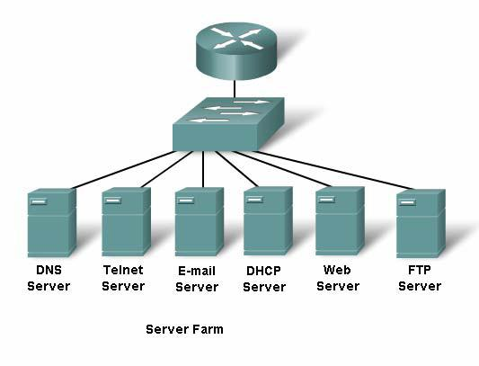

3.1 Application – The Interface Between the Networks
3.1.2 Application Layer Software :-

The functions associated with the Application layer protocols enable our human network

to interface with the underlying data network. When we open a web browser or an instant message window, an application is started, and the program is put into the device's memory where it is executed. Each executing program loaded on a device is referred to as a process.
Within the Application layer, there are two forms of software programs or processes that

provide access to the network: applications and services.

Network-Aware Applications

Applications are the software programs used by people to communicate over the network. Some end-user applications are network-aware, meaning that they implement the application layer protocols and are able to communicate directly with the lower layers of the protocol stack.
E-mail clients and web browsers are examples of these types of applications.

Application layer Services

Other programs may need the assistance of Application layer services to use network resources, like file transfer or network print spooling. Though transparent to the user, these services are the programs that interface with the network and prepare the data for transfer. Different types of data - whether it is text, graphics, or video - require different network services to ensure that it is properly prepared for processing by the functions occurring at the lower layers of OSI model.
Each application or network service uses protocols which define the standards and data formats to be used. Without protocols, the data network would not have a common way to format and direct data. In order to understand the function of various network services, it is necessary to become familiar with the underlying protocols that govern their operation.
Rollover the buttons in the figure to view examples.

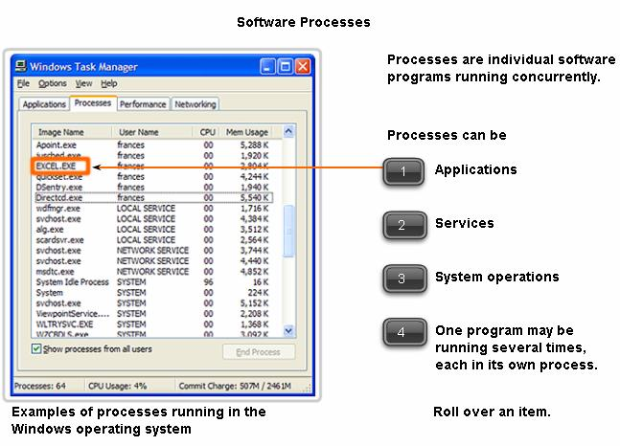

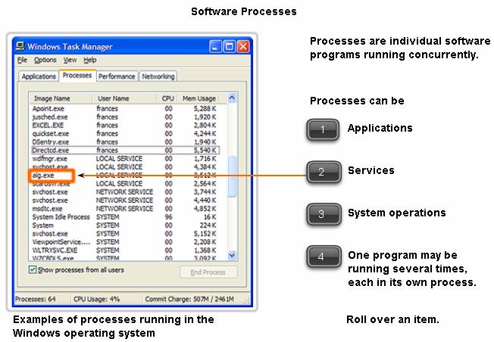

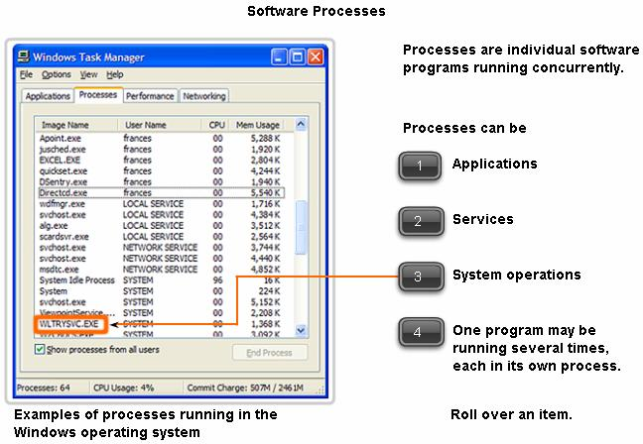

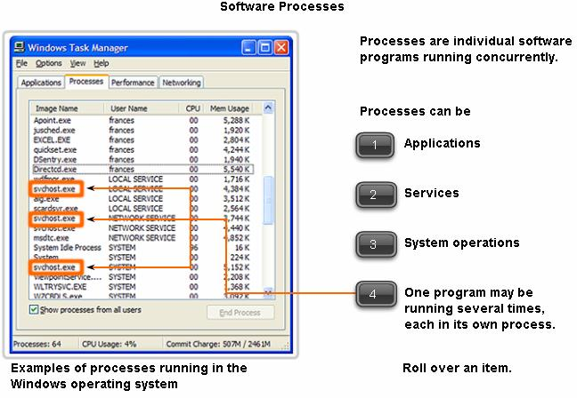

3.1 Application – The Interface Between the Networks
3.1.3 User Applications, Services and Application Layer Protocol
within applications and services. While applications provide people a way to create messages and application layer services establish an interface to the network, protocols provide
the rules and formats that govern how data is treated. All three components may be used by a single executable program and may even use the same name. For example, when discussing
"Telnet" we could be referring to the application, the service, or the protocol.

In the OSI model, applications that interact directly with people are considered to be at

the top of the stack, as are the people themselves. Like all layers within the OSI model, the Application layer relies on the functions of the lower layers in order to complete the communication process. Within the Application layer, protocols specify what messages are exchanged between the source and destination hosts, the syntax of the control commands, the type and format of the data being transmitted, and the appropriate methods for error notification
and recovery.

3.1 Application – The Interface Between the Networks
3.1.4 Application Layer Protocol Functions :-
Application layer protocols are used by both the source and destination devices during a communication session. In order for the communications to be successful, the application layer protocols implemented on the source and destination host must match.
Protocols establish consistent rules for exchanging data between applications and services loaded on the participating devices. Protocols specify how data inside the messages is structured
and the types of messages that are sent between source and destination. These messages can be
requests for services, acknowledgments, data messages, status messages, or error messages. Protocols also define message dialogues, ensuring that a message being sent is met by the expected response and the correct services are invoked when data transfer occurs.
Many different types of applications communicate across data networks. Therefore, Application layer services must implement multiple protocols to provide the desired range of communication experiences. Each protocol has a specific purpose and contains the characteristics required to meet that purpose. The right protocol details in each layer must be followed so that the functions at one layer interface properly with the services in the lower
layer.
Applications and services may also use multiple protocols in the course of a single

conversation. One protocol may specify how to establish the network connection and another describe the process for the data transfer when the message is passed to the next lower layer.

3.2 Making Provisions for Applications and Services
3.2.1 The Client – Server Model :-
When people attempt to access information on their device, whether it is a PC, laptop,

PDA, cell phone, or some other device connected to a network, the data may not be physically stored on their device. If that is the case, a request to access that information must be made to
the device where the data resides.

The Client/Server model

In the client/server model, the device requesting the information is called a client and the device responding to the request is called a server. Client and server processes are considered to
be in the Application layer. The client begins the exchange by requesting data from the server, which responds by sending one or more streams of data to the client. Application layer

protocols describe the format of the requests and responses between clients and servers. In

addition to the actual data transfer, this exchange may also require control information, such as user authentication and the identification of a data file to be transferred.
One example of a client/server network is a corporate environment where employees use

a company e-mail server to send, receive and store e-mail. The e-mail client on an employee computer issues a request to the e-mail server for any unread mail. The server responds by sending the requested e-mail to the client.

Although data is typically described as flowing from the server to the client, some data always flows from the client to the server. Data flow may be equal in both directions, or may even be greater in the direction going from the client to the server. For example, a client may transfer a file to the server for storage purposes. Data transfer from a client to a server is referred to as an upload and data from a server to a client as a download.

3.2 Making Provisions for Applications and Services
3.2.2 Servers :-
In a general networking context, any device that responds to requests from client applications is functioning as a server. A server is usually a computer that contains information to be shared with many client systems. For example, web pages, documents, databases, pictures, video, and audio files can all be stored on a server and delivered to requesting clients. In other cases, such as a network printer, the print server delivers the client print requests to the specified printer.
Different types of server applications may have different requirements for client access.

Some servers may require authentication of user account information to verify if the user has permission to access the requested data or to use a particular operation. Such servers rely on a central list of user accounts and the authorizations, or permissions, (both for data access and operations) granted to each user.

When using an FTP client, for example, if you request to upload data to the FTP server, you may have permission to write to your individual folder but not to read other files on the site.

In a client/server network, the server runs a service, or process, sometimes called a server daemon. Like most services, daemons typically run in the background and are not under an end user's direct control. Daemons are described as "listening" for a request from a client, because they are programmed to respond whenever the server receives a request for the service provided
by the daemon. When a daemon "hears" a request from a client, it exchanges appropriate

messages with the client, as required by its protocol, and proceeds to send the requested data to

the client in the proper format.

3.2 Making Provisions for Applications and Services
3.2.3 Application Layer Services and Protocols :-

A single application may employ many different supporting Application layer services;

thus what appears to the user as one request for a web page may, in fact, amount to dozens of individual requests. And for each request, multiple processes may be executed. For example, a client may require several individual processes to formulate just one request to a server.
Additionally, servers typically have multiple clients requesting information at the same time. For example, a Telnet server may have many clients requesting connections to it. These individual client requests must be handled simultaneously and separately for the network to succeed. The Application layer processes and services rely on support from lower layer functions to successfully manage the multiple conversations.

3.2 Making Provisions for Applications and Services
3.2.4 Peer – To – Peer Networking and Application (p2p) :-
The Peer-to-Peer Model

In addition to the client/server model for networking, there is also a peer-to-peer model. Peer-to-peer networking involves two distinct forms: peer-to-peer network design and peer-to- peer applications (P2P). Both forms have similar features but in practice work very differently.
Peer-to-Peer Networks

In a peer-to-peer network, two or more computers are connected via a network and can share resources (such as printers and files) without having a dedicated server. Every connected
end device (known as a peer) can function as either a server or a client. One computer might

assume the role of server for one transaction while simultaneously serving as a client for another. The roles of client and server are set on a per request basis.
A simple home network with two connected computers sharing a printer is an example of

a peer-to-peer network. Each person can set his or her computer to share files, enable networked games, or share an Internet connection. Another example of peer-to-peer network functionality
is two computers connected to a large network that use software applications to share resources between one another through the network.
Unlike the client/server model, which uses dedicated servers, peer-to-peer networks decentralize the resources on a network. Instead of locating information to be shared on dedicated servers, information can be located anywhere on any connected device. Most of the current operating systems support file and print sharing without requiring additional server software. Because peer-to-peer networks usually do not use centralized user accounts, permissions, or monitors, it is difficult to enforce security and access policies in networks containing more than just a few computers. User accounts and access rights must be set individually on each peer device.

Peer-to-Peer Applications

A peer-to-peer application (P2P), unlike a peer-to-peer network, allows a device to act as both a client and a server within the same communication. In this model, every client is a server
and every server a client. Both can initiate a communication and are considered equal in the communication process. However, peer-to-peer applications require that each end device provide a user interface and run a background service. When you launch a specific peer-to-peer application it invokes the required user interface and background services. After that the devices
can communicate directly.

Some P2P applications use a hybrid system where resource sharing is decentralized but

the indexes that point to resource locations are stored in a centralized directory. In a hybrid system, each peer accesses an index server to get the location of a resource stored on another peer. The index server can also help connect two peers, but once connected, the communication takes place between the two peers without additional communication to the index server.
Peer-to-peer applications can be used on peer-to-peer networks, client/server networks, and across the Internet.

3.3 Application Layer Protocols and Services Examples
3.3.1 DNS Services and Protocols :-
Now that we have a better understanding of how applications provide an interface for the

user and provide access to the network, we will take a look at some specific commonly used protocols.
As we will see later in this course, the Transport layer uses an addressing scheme called a port number. Port numbers identify applications and Application layer services that are the source and destination of data. Server programs generally use predefined port numbers that are commonly known by clients. As we examine the different TCP/IP Application layer protocols
and services, we will be referring to the TCP and UDP port numbers normally associated with

these services. Some of these services are:

▪ Domain Name System (DNS) - TCP/UDP Port 53

▪ Hypertext Transfer Protocol (HTTP) - TCP Port 80

▪ Simple Mail Transfer Protocol (SMTP) - TCP Port 25

▪ Post Office Protocol (POP) - UDP Port 110

▪ Telnet - TCP Port 23

▪ Dynamic Host Configuration Protocol - UDP Port 67

▪ File Transfer Protocol (FTP) - TCP Ports 20 and 21

DNS

In data networks, devices are labeled with numeric IP addresses, so that they can participate in sending and receiving messages over the network. However, most people have a hard time remembering this numeric address. Hence, domain names were created to convert the numeric address into a simple, recognizable name.
On the Internet these domain names, such as www.AAA.com , are much easier for people

to remember than 198.132.219.25, which is the actual numeric address for this server. Also, if AAA decides to change the numeric address, it is transparent to the user, since the domain name will remain www.AAA.com . The new address will simply be linked to the existing domain name and connectivity is maintained. When networks were small, it was a simple task
to maintain the mapping between domain names and the addresses they represented. However,

as networks began to grow and the number of devices increased, this manual system became unworkable.
The Domain Name System (DNS) was created for domain name to address resolution for

these networks. DNS uses a distributed set of servers to resolve the names associated with these numbered addresses.
The DNS protocol defines an automated service that matches resource names with the

required numeric network address. It includes the format for queries, responses, and data formats. DNS protocol communications use a single format called a message. This message format is used for all types of client queries and server responses, error messages, and the transfer of resource record information between servers.

DNS is a client/server service; however, it differs from the other client/server services

that we are examining. While other services use a client that is an application (such as web browser, e-mail client), the DNS client runs as a service itself. The DNS client, sometimes called the DNS resolver, supports name resolution for our other network applications and other services that need it.
When configuring a network device, we generally provide one or more DNS Server addresses that the DNS client can use for name resolution. Usually the Internet service provider provides the addresses to use for the DNS servers. When a user's application requests to connect
to a remote device by name, the requesting DNS client queries one of these name servers to

resolve the name to a numeric address.

Computer operating systems also have a utility called nslookup that allows the user to manually query the name servers to resolve a given host name. This utility can also be used to troubleshoot name resolution issues and to verify the current status of the name servers.
In the figure, when the nslookup is issued, the default DNS server configured for your host is displayed. In this example, the DNS server is dns-sjk.AAA.com which has an address of
171.68.226.120.

We then can type the name of a host or domain for which we wish to get the address. In

the first query in the figure, a query is made for www.AAA.com. The responding name server provides the address of 198.133.219.25.
The queries shown in the figure are only simple tests. The nslookup has many options

available for extensive testing and verification of the DNS process.

A DNS server provides the name resolution using the name daemon, which is often

called named, (pronounced name-dee).

The DNS server stores different types of resource records used to resolve names. These records contain the name, address, and type of record.
Some of these record types are:

▪ A - an end device address

▪ NS - an authoritative name server

▪ CNAME - the canonical name (or Fully Qualified Domain Name) for an alias; used when multiple services have the single network address but each service has its own entry
in DNS

▪ MX - mail exchange record; maps a domain name to a list of mail exchange servers for that domain
When a client makes a query, the server's "named" process first looks at its own records

to see if it can resolve the name. If it is unable to resolve the name using its stored records, it contacts other servers in order to resolve the name.

The request may be passed along to a number of servers, which can take extra time and

consume bandwidth. Once a match is found and returned to the original requesting server, the server temporarily stores the numbered address that matches the name in cache.
If that same name is requested again, the first server can return the address by using the

value stored in its name cache. Caching reduces both the DNS query data network traffic and

the workloads of servers higher up the hierarchy. The DNS Client service on Windows PCs optimizes the performance of DNS name resolution by storing previously resolved names in memory, as well. The ipconfig /displaydns command displays all of the cached DNS entries on
a Windows XP or 2000 computer system. .

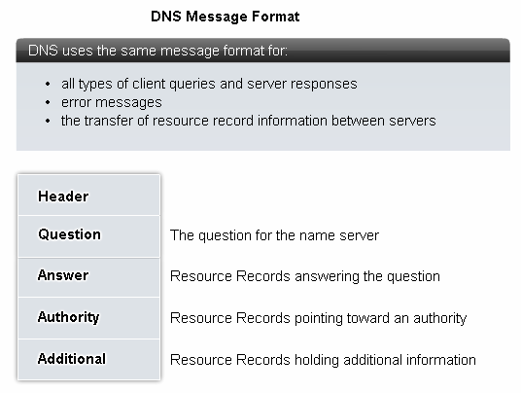

The Domain Name System uses a hierarchical system to create a name database to

provide name resolution. The hierarchy looks like an inverted tree with the root at the top and branches below.
At the top of the hierarchy, the root servers maintain records about how to reach the top- level domain servers, which in turn have records that point to the secondary level domain servers and so on.
The different top-level domains represent the either the type of organization or the country or origin. Examples of top-level domains are:
.au - Australia

.co - Colombia

.com - a business or industry

.jp - Japan

.org - a non-profit organization

After top-level domains are second-level domain names, and below them are other lower level domains.
Each domain name is a path down this inverted tree starting from the root.

For example, as shown in the figure, the root DNS server may not know exactly where

the e-mail server mail.AAA.com is located, but it maintains a record for the "com" domain within the top-level domain. Likewise, the servers within the "com" domain may not have a record for mail.AAA.com, but they do have a record for the "AAA.com" domain. The servers within the AAA.com domain have a record (a MX record to be precise) for mail.AAA.com.
The Domain Name System relies on this hierarchy of decentralized servers to store and maintain these resource records. The resource records list domain names that the server can resolve and alternative servers that can also process requests. If a given server has resource records that correspond to its level in the domain hierarchy, it is said to be authoritative for those records.

For example, a name server in the AAA.netacad.net domain would not be authoritative

for the mail.AAA.com record because that record is held at a higher domain level server.

3.3 Application Layer Protocols and Services Examples
3.3.2 WWW Service and HTTP :-
When a web address (or URL) is typed into a web browser, the web browser establishes a connection to the web service running on the server using the HTTP protocol. URLs (or Uniform Resource Locator) and URIs (Uniform Resource Identifier) are the names most people associate with web addresses.
The URL http://www.AAA.com/index.html is an example of a URL that refers to a

specific resource - a web page named index.html on a server identified as AAA.com (click the tabs in the figure to see the steps used by HTTP).
Web browsers are the client applications our computers use to connect to the World Wide

Web and access resources stored on a web server. As with most server processes, the web server runs as a background service and makes different types of files available.
In order to access the content, web clients make connections to the server and request the desired resources. The server replies with the resources and, upon receipt, the browser interprets
the data and presents it to the user.

Browsers can interpret and present many data types, such as plain text or Hypertext Markup Language (HTML, the language in which web pages are constructed). Other types of data, however, may require another service or program, typically referred to as plug-ins or add- ons. To help the browser determine what type of file it is receiving, the server specifies what kind of data the file contains.
To better understand how the web browser and web client interact, we can examine how

a web page is opened in a browser. For this example, we will use the URL:

http://www.AAA.com/web-server.htm.

First, the browser interprets the three parts of the URL:

1. http (the protocol or scheme)

2. www.AAA.com(the server name)

3. web-server.htm (the specific file name requested).

The browser then checks with a name server to convert www.AAA.com

<http://www.AAA.com > into a numeric address, which it uses to connect to the server. Using

the HTTP protocol requirements, the browser sends a GET request to the server and asks for the

file web-server.htm. The server in turn sends the HTML code for this web page to the browser. Finally, the browser deciphers the HTML code and formats the page for the browser window.

The Hypertext Transfer Protocol (HTTP), one of the protocols in the TCP/IP suite, was

originally developed to publish and retrieve HTML pages and is now used for distributed, collaborative information systems. HTTP is used across the WWW for data transfer and is one
of the most used application protocols.

HTTP specifies a request/response protocol. When a client, typically a web browser, sends a request message to a server, the HTTP protocol defines the message types the client uses to request the web page and also the message types the server uses to respond. The three common message types are GET, POST, and PUT.
GET is a client request for data. A web browser sends the GET message to request pages from a web server. As shown in the figure, once the server receives the GET request, it responds with a status line, such as HTTP/1.1 200 OK, and a message of its own, the body of which may be the requested file, an error message, or some other information.

POST and PUT are used to send messages that upload data to the web server. For

example, when the user enters data into a form embedded in a web page, POST includes the data in the message sent to the server.
PUT uploads resources or content to the web server.

Although it is remarkably flexible, HTTP is not a secure protocol. The POST messages upload information to the server in plain text that can be intercepted and read. Similarly, the server responses, typically HTML pages, are also unencrypted.
For secure communication across the Internet, the Secure HTTP (HTTPS) protocol is used for accessing or posting web server information. HTTPS can use authentication and encryption to secure data as it travels between the client and server. HTTPS specifies additional rules for passing data between the Application layer and the Transport Layer.

3.3 Application Layer Protocols and Services Examples
3.3.3 E-mail Services and SMTP/POP Protocols :-

E-mail, the most popular network service, has revolutionized how people communicate

through its simplicity and speed. Yet to run on a computer or other end device, e-mail requires several applications and services. Two example Application layer protocols are Post Office Protocol (POP) and Simple Mail Transfer Protocol (SMTP), shown in the figure. As with HTTP, these protocols define client/server processes.
When people compose e-mail messages, they typically use an application called a Mail User Agent (MUA), or e-mail client. The MUA allows messages to be sent and places received messages into the client's mailbox, both of which are distinct processes.
In order to receive e-mail messages from an e-mail server, the e-mail client can use POP.

Sending e-mail from either a client or a server uses message formats and command strings defined by the SMTP protocol. Usually an e-mail client provides the functionality of both protocols within one application.

E-mail Server Processes - MTA and MDA

The e-mail server operates two separate processes: Mail Transfer Agent (MTA)
Mail Delivery Agent (MDA)

The Mail Transfer Agent (MTA) process is used to forward e-mail. As shown in the figure, the MTA receives messages from the MUA or from another MTA on another e-mail server. Based on the message header, it determines how a message has to be forwarded to reach
its destination. If the mail is addressed to a user whose mailbox is on the local server, the mail is passed to the MDA. If the mail is for a user not on the local server, the MTA routes the e-mail
to the MTA on the appropriate server.

In the figure, we see that the Mail Delivery Agent (MDA) accepts a piece of e-mail from

a Mail Transfer Agent (MTA) and performs the actual delivery. The MDA receives all the inbound mail from the MTA and places it into the appropriate users' mailboxes. The MDA can also resolve final delivery issues, such as virus scanning, spam filtering, and return-receipt handling. Most e-mail communications use the MUA, MTA, and MDA applications. However, there are other alternatives for e-mail delivery.

A client may be connected to a corporate e-mail system, such as IBM's Lotus Notes, Novell's Groupwise, or Microsoft's Exchange. These systems often have their own internal e- mail format, and their clients typically communicate with the e-mail server using a proprietary protocol.

The server sends or receives e-mail via the Internet through the product's Internet mail

gateway, which performs any necessary reformatting. If, for example, two people who work for

the same company exchange e-mail with each other using a proprietary protocol, their messages may stay completely within the company's corporate e-mail system.
As another alternative, computers that do not have an MUA can still connect to a mail service on a web browser in order to retrieve and send messages in this manner. Some computers may run their own MTA and manage inter-domain e-mail themselves.

As mentioned earlier, e-mail can use the protocols, POP and SMTP (see the figure for an

explanation of how they each work). POP and POP3 (Post Office Protocol, version 3) are inbound mail delivery protocols and are typical client/server protocols. They deliver e-mail from the e-mail server to the client (MUA). The MDA listens for when a client connects to a server. Once a connection is established, the server can deliver the e-mail to the client.
The Simple Mail Transfer Protocol (SMTP), on the other hand, governs the transfer of outbound e-mail from the sending client to the e-mail server (MDA), as well as the transport of
e-mail between e-mail servers (MTA). SMTP enables e-mail to be transported across data networks between different types of server and client software and makes e-mail exchange over
the Internet possible.

The SMTP protocol message format uses a rigid set of commands and replies. These commands support the procedures used in SMTP, such as session initiation, mail transaction, forwarding mail, verifying mailbox names, expanding mailing lists, and the opening and closing exchanges.

Some of the commands specified in the SMTP protocol are:

• HELO - identifies the SMTP client process to the SMTP server process

• EHLO - Is a newer version of HELO, which includes services extensions

• MAIL FROM - Identifies the sender

• RCPT TO - Identifies the recipient

• DATA - Identifies the body of the message

3.3 Application Layer Protocols and Services Examples
3.3.4 FTP :-

The File Transfer Protocol (FTP) is another commonly used Application layer protocol. FTP was developed to allow for file transfers between a client and a server. An FTP client is an application that runs on a computer that is used to push and pull files from a server running the FTP daemon (FTPd).
To successfully transfer files, FTP requires two connections between the client and the server: one for commands and replies, the other for the actual file transfer.
The client establishes the first connection to the server on TCP port 21. This connection

is used for control traffic, consisting of client commands and server replies.

The client establishes the second connection to the server over TCP port 20. This connection is for the actual file transfer and is created every time there is a file transferred.
The file transfer can happen in either direction. The client can download (pull) a file from

the server or, the client can upload (push) a file to the server.

3.4.1 Summary and Review :-

The Application layer is responsible for directly accessing the underlying processes that manage and deliver communication to the human network. This layer serves as the source and destination of communications across data networks.
The Application layer applications, protocols, and services enable users to interact with the data network in a way that is meaningful and effective.
Applications are computer programs with which the user interacts and which initiate the

data transfer process at the user's request.

Services are background programs that provide the connection between the Application layer and the lower layers of the networking model.
Protocols provide a structure of agreed-upon rules and processes that ensure services running on one particular device can send and receive data from a range of different network devices.

Delivery of data over the network can be requested from a server by a client, or between

devices that operate in a peer-to-peer arrangement, where the client/server relationship is established according to which device is the source and destination at that time. Messages are exchanged between the Application layer services at each end device in accordance with the protocol specifications to establish and use these relationships.
Protocols like HTTP, for example, support the delivery of web pages to end devices. SMTP/POP protocols support sending and receiving e-mail. SMB enables users to share files. DNS resolves the human legible names used to refer to network resources into numeric addresses usable by the network.

